# CS 255 System Design Document Template

This template lays out all the different sections that you need to complete for Project Two. Each section has guidance to prompt your thinking. You will need to continually reference the interview transcript as you work to make sure that you are addressing your client’s needs. There is no required length for the final document. Instead the goal is to complete each section based on what your client’s needs are. Remove this note when you are finished, and replace all bracketed text with the relevant information.

## UML Diagrams

### UML Use Case Diagram

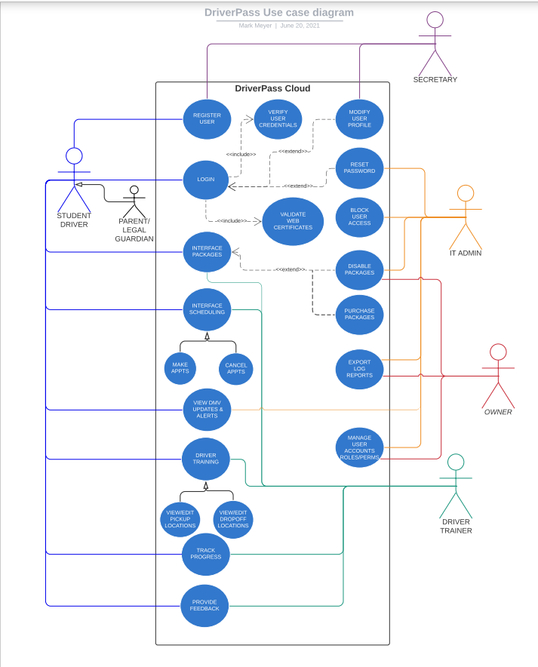

### UML Activity Diagrams

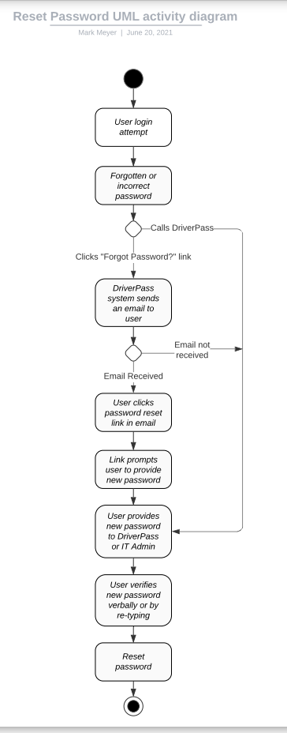

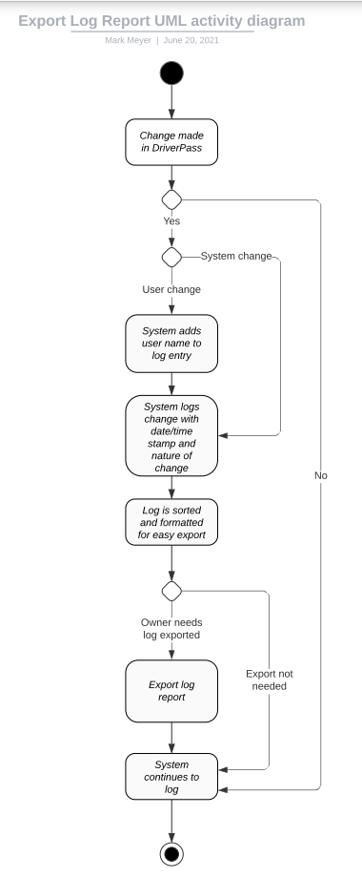

### UML Sequence Diagram

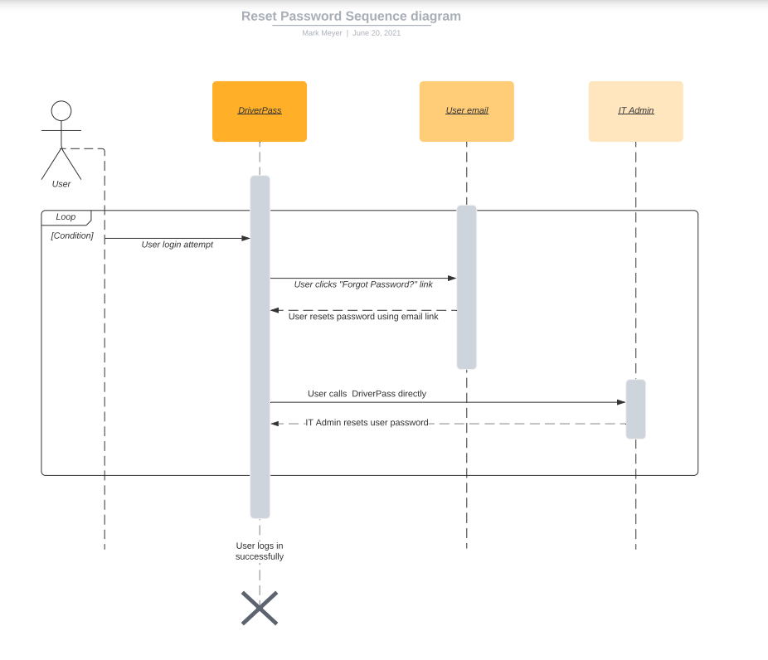

### UML Class Diagram

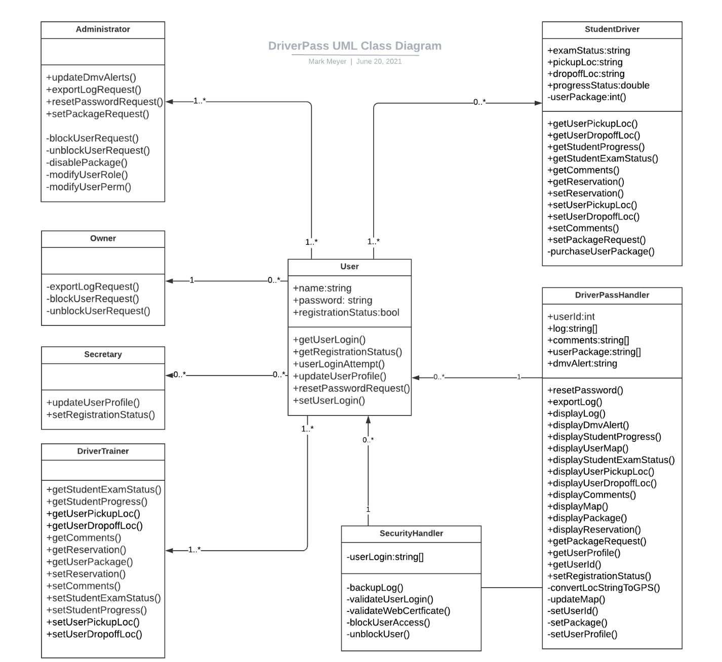

## Technical Requirements

The diagrams above convey an overall mapping of the DriverPass web application. The technical requirements for this system are as follows:

* **Hardware:** This system will developed to reside on the cloud. Therefore, the hardware required will be versatile. The application will be available on any device supporting an internet connection and will only be limited to the internet speed and processing power of the device, rather than worrying about what type of platform it is operating upon. This allows the application to be reached by a wider audience. This is ideal given the nature of the service offered.
* **Software:** The system will not require users to download any additional software. The only requirement to access the system is to have a device that supports an internet connection and can run a normal web application, ideally at broadband speeds or higher.
* **Tools:** The system utilizes several tools across all users including but not limited to:
  + User registration
  + User login validation
  + User password reset
  + User role/permissions control
  + User profile modification
  + Blocking unwanted user access
  + Web certificate validation
  + Logging system changes for visibility and export
  + System log backup support
  + Map support for viewing and changing pickup and drop off locations
  + Package purchasing/disabling
  + Making/cancelling reservations
  + Feedback between student and trainer using a comment forum
  + Progress tracking
  + Exam status visibility
  + DMV alert system
* **Infrastructure:** The DriverPass system architecture is designed in a way that most of the processing is handled on the server side. The reason for this is since the system is built upon the cloud, you do not want to rely heavily on the internet connection for application processes. Instead, you want the server to do the heavy lifting, and then each user account only needs to access what it needs when necessary. Notice the DriverPassHandler and SecurityHandler classes combine to provide a collaborative systemic effort in making sure each user account is not burdened with repetitive process handling. The handlers act as a centralized hub of process management.